Question 1: Open the Firefox browser, navigate to Google page

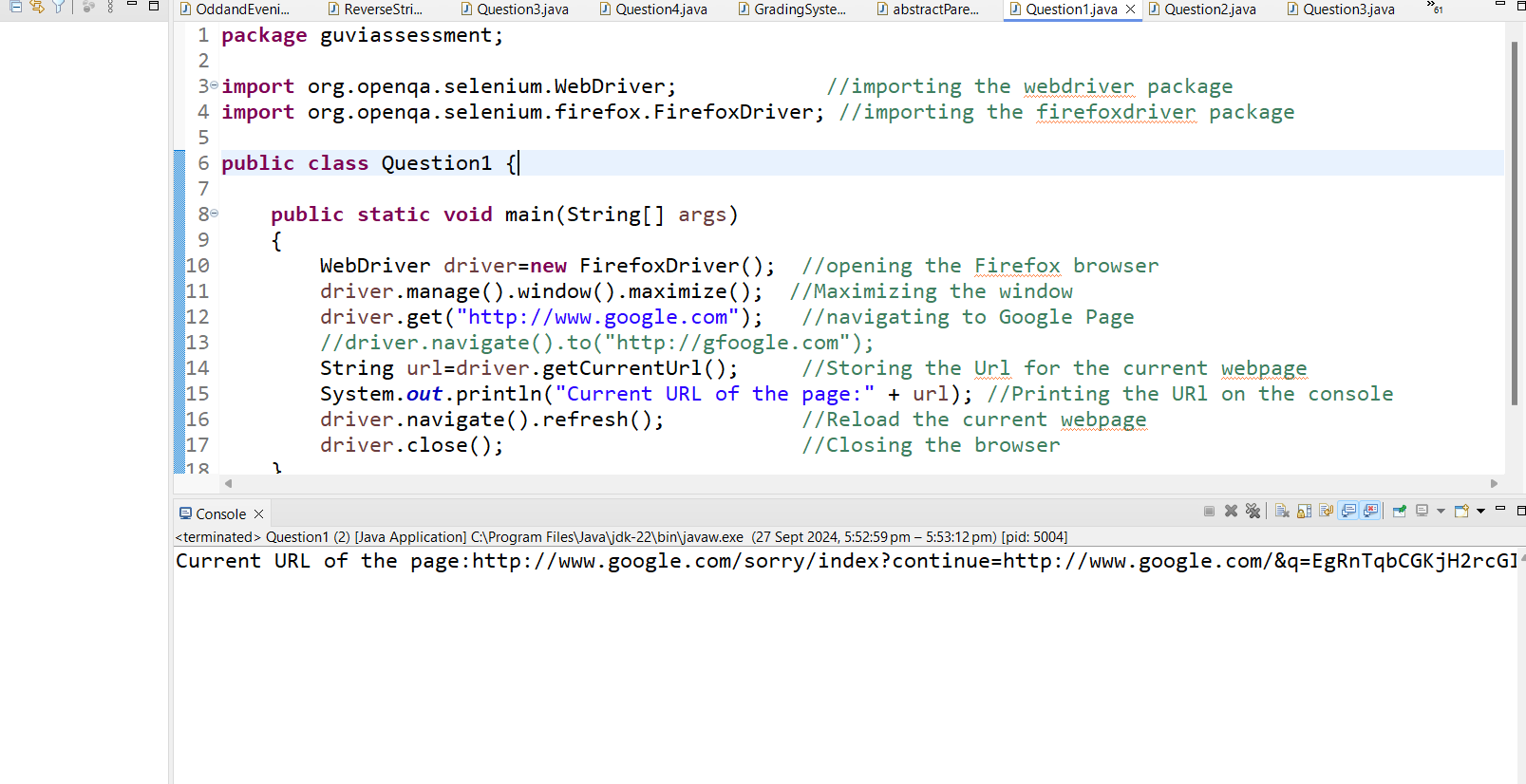

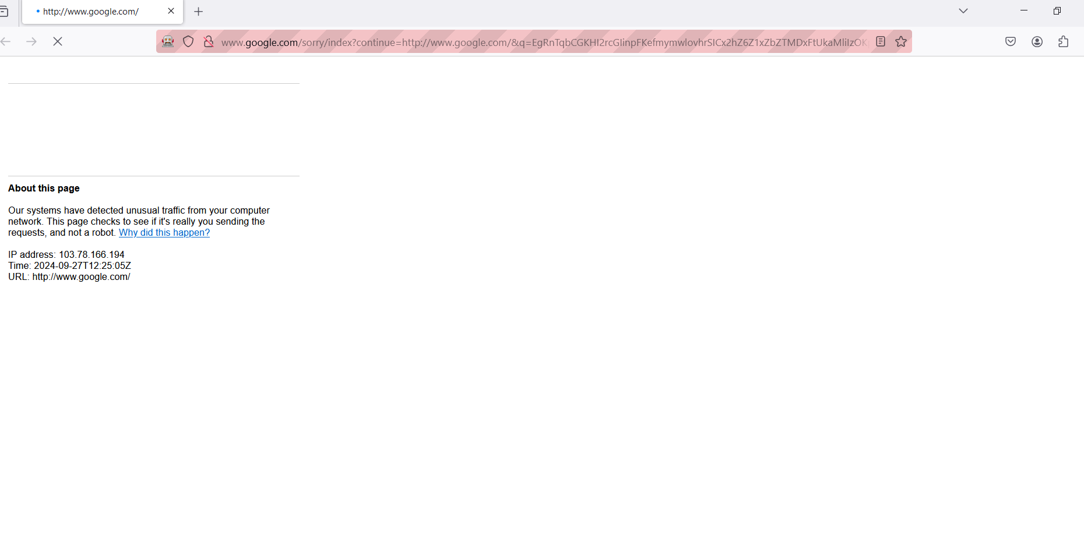

Question 2: Open the Chrome browser and get into the demoblaze site to verify the title of the page

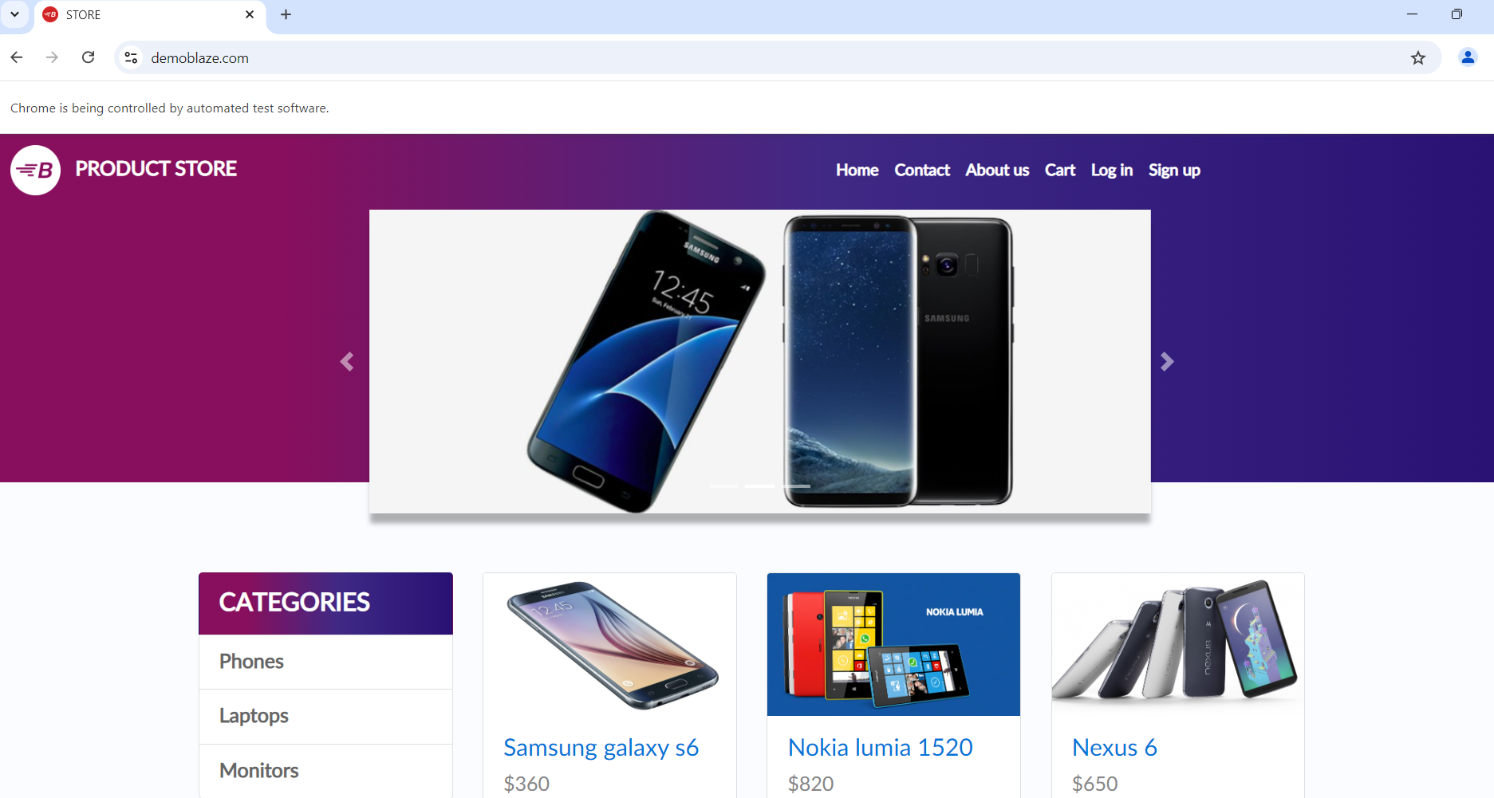

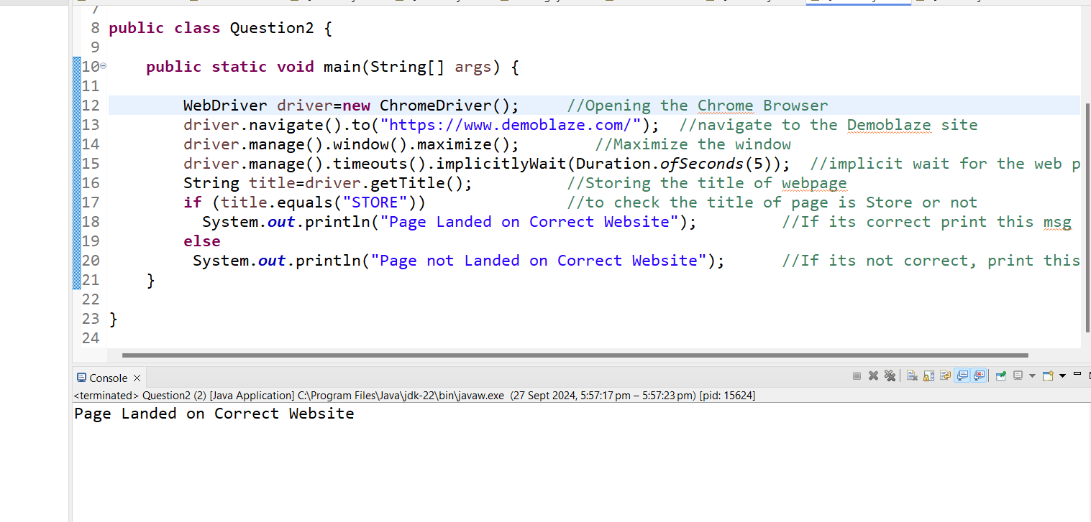

Question 3: Open the Chrome browser and navigate to Wikipedia to search the artificial intelligence and printing the section of title, while clicking the History.

